R.S.C.D.S. Oban & Lorn Branch

61st Weekend School
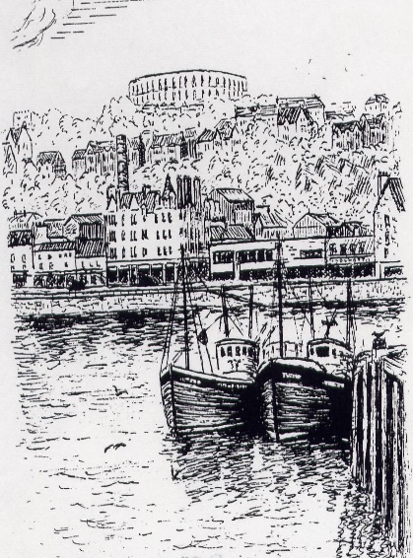

10th & 11th March 2023
Corran Halls, Oban

Friday 10th March

Social Dance 8pm ~ 11pm Marian Anderson’s Band

Saturday 11th March
Class 1 9:30am ~ 11am Class 2 11: 20am ~ 12:50pm

Teacher Janet Johnston Musician Martainn Skene

Buffet Dance 6.30pm ~ 11.30pm Ewan Galloway’s Band

Recognised Scottish Charity No. SC025326

No liability is held by the Oban & Lorn Branch for accident or loss of personal property at these events.

Basic steps & formations are required.

R.S.C.D.S. Oban and Lorn Branch would like to invite dancers to join them for their 61st Weekend School.

Friday night will welcome you with the music of Marian Anderson’s Band.
A light supper of home baking will be served.

Saturday classes will be taught by Janet Johnston with accompaniment by Martainn Skene. Janet and Martainn are both experienced in dayschools as well as kent faces on the staff at Summer School in St Andrews and abroad.

Saturday night will welcome Ewan Galloway’s Band with a buffet meal served at 6.30pm.

All dances will be recapped both nights. Crib sheets will be available on the branch website www.rscdsoban.com .

Bar facilities not be available on Saturday night. It is not permitted to bring alcohol into the hall. Please bring your own water throughout the weekend.

Oban & Lorn Branch looks forward to welcoming dancers coming for the first time to Oban and renewing friendships from previous years.

Friday Social Dance Saturday Buffet Dance
EH3 7AF J 40 Good Hearted Glasgow J Guide to SCD
Portnacraig R 36 Back to the Fireside R 38
Miss Milligan’s Strathspey S 20 The Gentleman S 35
The Laird of Milton’s Daughter J 22 Farewell to Balfour Road J 52
The Ladies of Dunse R 26 The Whistling Wind R 36
Gaelic Mod S Imp 5 Linnea’s Strathspey S 47
The Duke of Atholl’s Reel J 16 Mrs Stewart’s Jig J 35
Maxwell’s Rant R 18 The Rev. John MacFarlane R 37
Homebaking supper Raffle
Miss Hadden’s Reel J 23 Light and Airy J 4
Flowers of Edinburgh R 1 Culla Bay S 41
Anna Holden’s Strathspey S 42 The Montgomeries’ Rant R 10
John Cass J 49 Gothenburg’s Welcome J 37
The Old Man of Storr R SCD The Braes of Tulliemet S 7
Children Scott Meikle R 46
Neidpath Castle S 22 Minister on the Loch S 2008
The Highlander Rambler R 30 Pop The Deil Amang the Tailors R 14
Application Form

 |  | No. of tickets | Cost
Weekend Package  dances & classes | Dancer £50  Discount * £44
Friday Social Dance | Dancer £15  Discount * £13  Non dancer £10
Saturday class 1 | Dancer £5  Discount * £4
Saturday class 2 | Dancer £5  Discount * £4
Saturday classes 1 & 2 | Dancer £9  Discount * £7
Saturday Buffet dance | Dancer £26  Discount * £24  Non dancer £24
 |  | Total amount enclosed
*Discount given to RSCDS Oban & Lorn Branch members & under 26 year old

Name & address …………………………………………………………………..

……………………………………………………………………………………..

……………………………………………………………………………………..

Tel No………………………………………………………………………………

Email ………………………………………………………………………………

Special dietary …………………………………………………………………….

Name ………………………………………………………………………………

Please list all those attending overleaf.
Return to Sue Porter, Schiehallion, Grianach Gardens, Oban, PA34 4LB
by 26th Feb 2023 with a S.A.E. Tel 01631 563103 mobile 07753593668
Cheques payable to RSCDS Oban and Lorn Branch. .No refund after 4/3/2020
Names of those attending event Tick if attending class

