R.S.C.D.S. Oban & Lorn Branch

62nd Weekend School
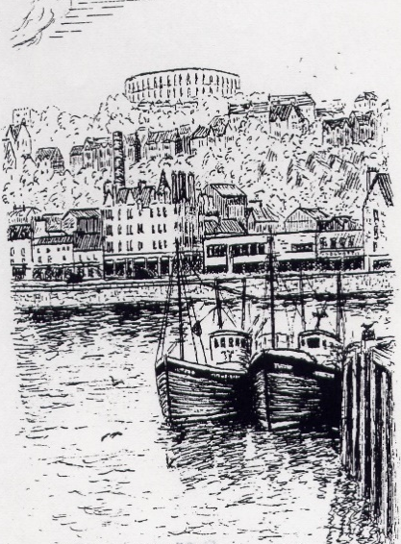

8th & 9th March 2024
Corran Halls, Oban

Friday 8th March

Social Dance 8pm ~ 11pm Susan MacFadyen’s Band

Saturday 9th March
Class 1 9:30am ~ 11am Class 2 11: 20am ~ 12:50pm

Teacher Fiona Mackie Musician Luke Brady

Buffet Dance 6.30pm ~ 11.30pm Luke Brady’s Band

Recognised Scottish Charity No. SC025326

No liability is held by the Oban & Lorn Branch for accident or loss of personal property at these events.

Basic steps & formations are required.

R.S.C.D.S. Oban and Lorn Branch would like to invite dancers to join them for their 62nd Weekend School.

Friday night will welcome you with the music of Susan MacFadyen’s Band.
A light supper of home baking will be served.

Saturday classes will be taught by Fiona Mackie with accompaniment by Luke Brady. Fiona and Luke are both experienced in dayschools as well as kent faces on the staff at Summer School in St Andrews and abroad.

Saturday night will welcome Luke Brady’s Band with a buffet meal served at 6.30pm.

All dances will be recapped both nights. Crib sheets will be available on the branch website www.rscdsoban.com .

Bar facilities not be available on Saturday night. It is not permitted to bring alcohol into the hall. Please bring your own water throughout the weekend.

Oban & Lorn Branch looks forward to welcoming dancers coming for the first time to Oban and renewing friendships from previous years.

Friday Social Dance Saturday Buffet Dance
The Shetland Shepherdess J Gr3 Hooper’s Jig J MMM
Festival Fling R 44 Suenos Stone R 2008
The Duchess Tree S Drewry Up in the Air S 20
The Wild Geese J 24 Speirs Bruce the Pole Star J Scotia Suite
Sleepy Maggie R 11 Peggy Dewar R 38
The Water of Leith S 53 Peggy Spouse MBE S 46
Flora’s Fancy J 49 Joie de Vivre J 39
The Kissing Bridge R 47 The Rev. John MacFarlane R 37
Homebaking supper Raffle
New Year Jig J 51 The Smiddy Jig J MacPherson
Flight to Melbourne R 47 Cape Town Wedding S 39
Linnea Strathspey S 47 General Stuart’s Reel R 10
Bill Clement MBE J 47 Urquhart Castle J Unknown
Blooms of Bon Accord R Drewry Bonnie Gallowa’ S 53
The Orchards of Co. Armagh S 53 Maxwell’s Rant R 18
Shiftin’ Bobbins R 30 Pop Hope Little’s Strathspey S Goldring
Highlander Rambler R 30 Pop
Application Form

 |  | No. of tickets | Cost
Weekend Package  dances & classes | Dancer £50  Discount * £44
Friday Social Dance | Dancer £15  Discount * £13  Non dancer £10
Saturday class 1 | Dancer £5  Discount * £4
Saturday class 2 | Dancer £5  Discount * £4
Saturday classes 1 & 2 | Dancer £9  Discount * £7
Saturday Buffet dance | Dancer £26  Discount * £24  Non dancer £24
 |  | Total amount enclosed
*Discount given to RSCDS Oban & Lorn Branch members & under 26 year old

Name & address …………………………………………………………………..

……………………………………………………………………………………..

……………………………………………………………………………………..

Tel No………………………………………………………………………………

Email ………………………………………………………………………………

Special dietary …………………………………………………………………….

Name for diet………………………………………………………………………

Please list all those attending overleaf.
Return to Sue Porter, Schiehallion, Grianach Gardens, Oban, PA34 4LB
by 23rd Feb 2024 with a S.A.E. Tel 01631 563103 mobile 07753593668

Cheques payable to Royal Scottish Country Dance Society Oban and Lorn Branch. ( no intials please) No refund after 26/2/2024

Names of those attending event Tick if attending class

