**R.S.C.D.S. Oban & Lorn Branch**

**63rd Weekend School**

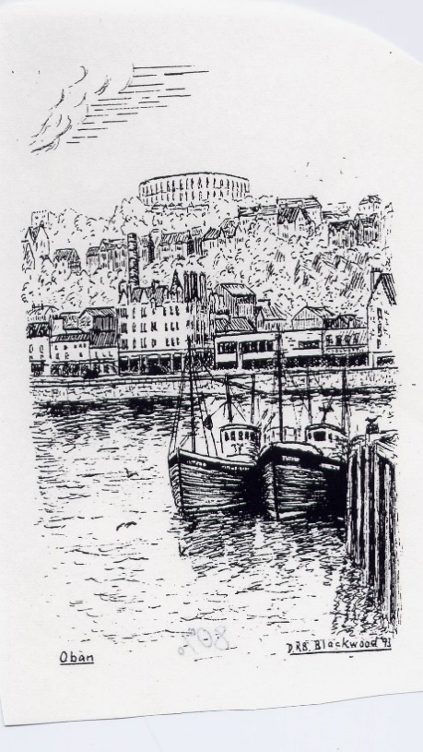

**14th & 15th March 2025**

**Corran Halls, Oban**

Friday 14th March

### Social Dance 8pm ~ 11pm **Lyndsay Weir’s Band**

Saturday 15th March

Class 1 9:30am ~ 11am Class 2 11: 20am ~ 12:50pm

### **Teacher Rachel Shankland Musician Michael Garvin**

# Buffet Dance 6.30pm ~ 11.30pm David Oswald’s Band

Recognised Scottish Charity No. SC025326

**No liability is held by the Oban & Lorn Branch for accident or loss of personal property at these** **events.**

Basic steps & formations are required.

R.S.C.D.S. Oban and Lorn Branch would like to invite dancers to join them for their 63rd Weekend School.

*Friday night* will welcome you with the music of Lyndsay Weir’s Band.

A light supper of home baking will be served.

*Saturday classes* will be taught by Rachel Shankland, Edinburgh with accompaniment by Michael Garvin, Oban.

*Saturday night* will welcome David Oswald’s Band with a buffet meal served at 6.30pm.

All dances will be recapped both nights. Crib sheets will be available on the branch website [www.rscdsoban.com](http://www.rscdsoban.com) .

Bar facilities not be available on Saturday night. It is not permitted to bring alcohol into the hall. Please bring your own water throughout the weekend.

Oban & Lorn Branch looks forward to welcoming dancers coming for the first time to Oban and renewing friendships from previous years.

**Friday Social Dance Saturday Buffet Dance**

Good Hearted Glasgow J GSCD The Shetland Shepherdess J Gr 3

The Sailor R 24 Back to the Fireside R 38

May Yarker’s Strathspey S 42 Cherrybank Gardens S30 Pop.Vol 2

Napier’s Index J 45 Fair Enough J 51

Reel On R Goldring Mr Iain Stuart Robertson R 42

Linnea’s Strathspey S 47 Miss Gibson’s Strathspey S RSCDS L

Welcome to Ayr J 47 Weekends in Oban J Porter

The Tri-Mariner R 48 Mary Erskine R Gr 2

*Homebaking supper Raffle*

Granville Market J Gr2 EH3 7AF J 40

Orpington Caledonians R 49 The Gardeners’ Fantasia S 46

The Gentleman S 35 The Ullapool Ferry R 52

Gaelforce Wind J Gr 3 A Capital Jig J 2009

Rest and be Thankful R Lft The Royal Wedding S 5 for 1982

Triple Happiness S 52 John of Bon Accord R 33

The Reel of the 51st Division R 13 The Orchards of Co. Armagh S 53

The Deil Amang the Tailors R 14

**Application Form**

|  |  |  |  |
| --- | --- | --- | --- |
|  |  | **No. of tickets** | **Cost** |
| **Weekend Package**  dances & classes | Dancer £50  Discount * £44 |  |  |
| **Friday Social Dance** | Dancer £15  Discount * £13  Non dancer £10 |  |  |
| **Saturday class 1** | Dancer £5  Discount * £4 |  |  |
| **Saturday class 2** | Dancer £5  Discount * £4 |  |  |
| **Saturday classes 1 & 2** | Dancer £9  Discount * £7 |  |  |
| **Saturday Buffet dance** | Dancer £26  Discount * £24  Non dancer £24 |  |  |
|  |  | **Total amount enclosed** |  |

**\*Discount** given to RSCDS Oban & Lorn Branch members & under 26 year old

Name & address …………………………………………………………………..

……………………………………………………………………………………..

Tel No………………………………………………………………………………

Email ………………………………………………………………………………

Special dietary …………………………………………………………………….

Name for diet………………………………………………………………………

Please list all those attending overleaf.

Return to Sue Porter, Schiehallion, Grianach Gardens, Oban, PA34 4LB

by **28th Feb 2025 with a S.A.E.** Tel 01631 563103 mobile 07753593668 Cheques payable to ***Royal Scottish Country Dance Society Oban and Lorn Branch.* ( no intials please)** No refund after 28/2/2025

**Names of those attending event Tick if attending class**